High-Base-Low Charts

This handout explains how to produce a High Base Low Chart using MS Excel.

Sample Problem:
You’ve done some analysis of different strategies for introducing the new cell phone to the market. There are 4 strategies to consider and after doing deterministic and probabilistic analysis, you’ve found the following information about the different strategies. You want to display these options on a chart so your decision makers can get a feel for the variability within the options.

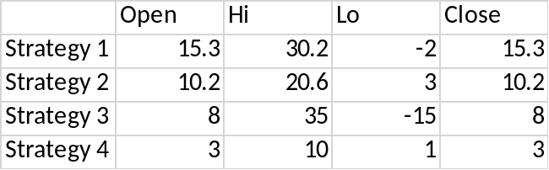

Procedures:
- Create chart above.
- In this scenario, the Open and Close will represent the Present Equivalent (PE) when all uncertainties are at their Base level. The High will represent when the uncertainties are all at their highest level, and the Lo will represent the PE at the lowest level. Finally, you’ll also represent the Certain Equivalent (CE) on this chart as well.
- Highlight the table select INSERT from the toolbar, then click the Recommended Charts button. In the dialogue box, click the header All Charts. Find Stock charts, and choose the Open-High-Low-Close chart, but make sure to click on the second option of Open-High-Low-Close chart. Then click OK.
- Right click on the X-Axis of the graph and select FORMAT AXIS, then, under Axis Options change Axis value (under vertical axis crosses) to the value of the profit function with all uncertainties at their base values (475 in our example).

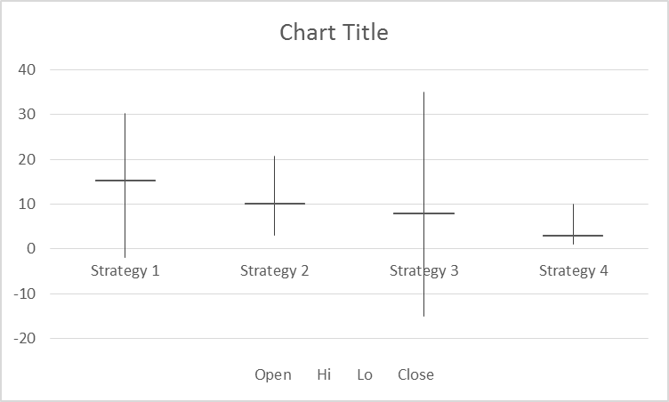

- Right click on tall vertical line on the graph and select Format High-Low Lines…, and under High-Low Lines Options, change Color to blue (or something besides black), and the Width to 33pt.
- Right click on Legend “Open Hi Lo Close,” and select Font. Pull the Font Color dropdown menu to white (or the same color of the background of your chart.

You are free to develop stylistic changes but you should see:

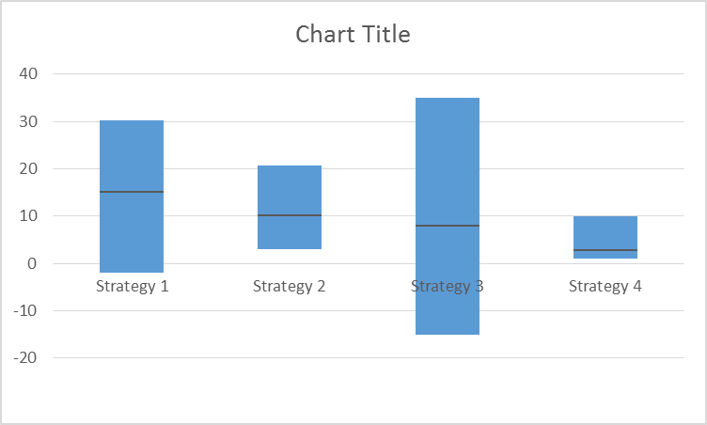

Make sure to include a chart title and axis legend.
- Finally, you will want to note your CE for each option on the graph. You can do this by selecting INSERT from the toolbar, then click on the Shapes dropdown menu. I’ve selected a star. Create a star anywhere on your spreadsheet, then you can change the color (I’ve chosen red). Copy the star for as many options as you have and manually place the stars on the chart to denote the CE for each strategy. When you go to copy this chart, or save it as a picture, make sure you highlight the stars along with the chart when you copy.

